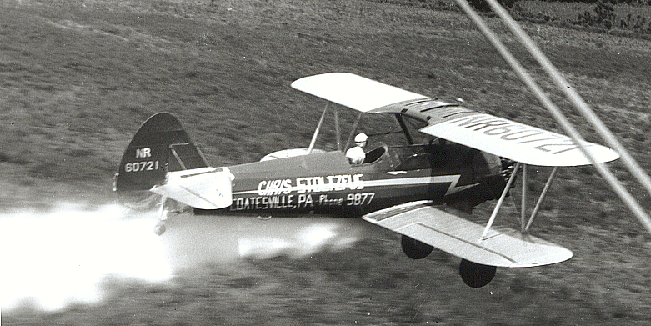

Ken Stoltzfus

An “Out”
No. 4 in a series
Daring to pursue the highest possible level in all of life
Flying Higher

My father, the late Chris D. Stoltzfus (1913-81), of Coatesville, Pennsylvania, was a pioneer crop duster. He learned to fly in the mid 1930’s, was a CPT (Civilian Pilot Training) instructor during WWII and began an impressive ag career just after the war.
Father flew a Travel Air 4000 duster for 3500 hours before retiring it in 1952. His ag fleet over the years included Cubs, an N3N, Stearmans, TBM’s, Twin Beech’s, C-47’s and Chase C-122’s. Two Grumman FM2 Wildcats and a B-17 were also in his repertoire but were never used for spraying.
Father was pretty thoughtful about life in general and was especially deliberate about his flying. He always knew what was going on around him.
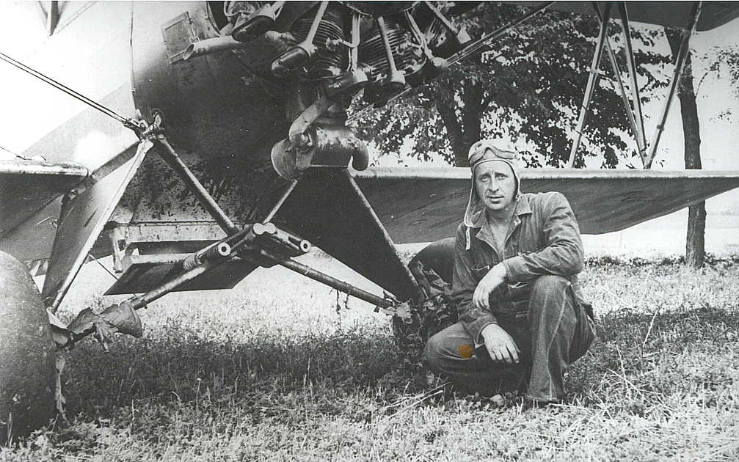
I remember the day in the 1950’s when he broke a rod on a 450-Stearman while spraying. His wheels were just above the corn tassels, yet he parked the airplane safely in a nearby hayfield. It was only one of several similar situations in his career, but he never bent an aircraft such that he couldn’t fly it home. More than one engine was changed “in the field,” literally!
Father, with the Travel Air 4000 he dusted with for 3500 hours!
I asked Father how he knew where to go that day. He said it was his practice to always know where his options were. He dusted countless fields, and part of his discipline was to survey each area and know where he would go if he had to. It wasn’t a big deal - - he just always wanted an “out!” Father taught me a lot and this was one of the gems!
There are some things about life that fascinate me. One biggy is that God made the “big three” so weighty in the human experience.
Money, sex and power add so much to life, yet they bring such risk! This world would be pretty dull without them, yet they are the primary culprits in most social problems.
Father didn’t refrain from dusting and spraying because of the risk. (I can’t resist inserting here that his mother once said, “Well, if he has to fly, I’m glad he’s dusting because at least he’s not so high.” He left well enough alone and never told her otherwise! ☺)
His approach to the risk of ag flying was to call it what it was, and take steps to minimize it. Being aware of what was going on around him was key to that. To ignore risk or to fail to plan for it could have been fatal for him on numerous occasions.
Money has almost breathtaking sway over humans. People will do nearly anything to get it and then lay awake at night worrying about how to keep it. Yet it is money that buys food, clothing and shelter for our families - - and through our generosity, provides for needy people around the world.
Sex is one of the most spectacular parts of all of creation. Its practical side in “replenishing the earth” harmonizes so well with its awesome, pleasurable side. Yet countless men and women know sadness beyond measure by the way they experience it.
When the power of position, wealth, stature, intellect, speech, beauty or any other source is used for the good of others, it can enrich all within its reach. Yet it will equally diminish and impoverish them when used selfishly.
In varying degrees money, sex and power are in the hands of each of us. And for each they bring risk. We vary some in which of the three creates the most vulnerability for us, but none of us is exempt.
There is a way to live well in spite of the risk. To experience money, sex and power in satisfying and rewarding ways. But it takes an awareness of what is going on inside of and around us. We need an honest appraisal of the risks and a plan to deal with them. And we need an "out."
The Bible, and especially the book of Proverbs offers interesting insights here. Practical, down to earth stuff. It speaks of generosity, greed and contentment. Of pure sexual pleasure and the consequences of immorality. Of using our resources to help others or to crush them. And it offers many stories of people who did well - - and others who messed up with the big three.
We have the Bible account of Joseph, "a very handsome and well-built young man," and the king's wife who "began to desire him and invited him to sleep with her." She persisted, he resisted. He knew his "out" and he took it. (Genesis 39-40)
The scriptures say, “But remember that the temptations that come into your life are no different from what others experience - - - when you are tempted, he will show you a way out so that you will not give in to it.” (I Corinthians 10:13)
He does! There is always a way out. There are safe places that our hands and feet can take us to. There are other pastures for our minds to graze in. And above all, God is ready to help those who call upon Him.
My father flew over 10,000 hours, accident free. Much of it was at low altitude in what we would now consider unreliable, antique aircraft. If we will approach life as thoughtfully as he did, we'll be able to enjoy the benefits of money, sex and power while avoiding the crashes which so many experience! 1999, rev. 7/10 - Bible quotations from NLT


Ken Stoltzfus was born in 1940, the son of a crop duster. He has worked as a pilot, pastor, business man, missionary to Africa and writer.
A Commercial Pilot with S&MEL&S, DC-3, Glider and Instrument ratings; CFI with A-I-G ratings; Ground Instructor A&I; and A&P, Ken lives in northeast Ohio with Elaine, his wife of 50 years. His hobbies are aviation photography and collecting aircraft photos, negatives and slides.
This is #4 in his “Flying Higher” series. ©2010, Ken Stoltzfus, www.John2031.com, P.O. Box 228, Kidron, OH 44636 USA

