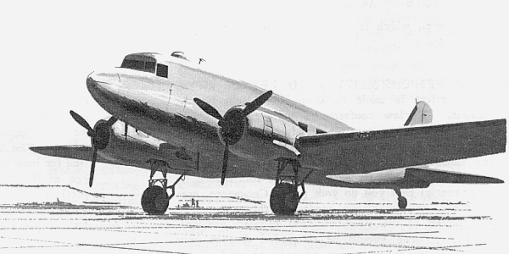

Ken Stoltzfus

Dummys For Pilots
No. 9 in a series
Daring to pursue the highest possible level in all of life
Flying Higher

Our family began using C-47’s for forest spraying in 1967. My first loads were out of Mt. Pocono, in eastern Pennsylvania. It was an adequate airport for this operation, but in spraying we always wanted to carry the maximum safe load and I was having a problem.
We had installed two long, 575-gallon spray tanks, but were only carrying 1000 gallon. With this being a taildragger, the liquid would go to the back of the tanks in a three-point attitude. Even with the two 1200-hp Wrights pulling as hard as they could, I was having a tough time getting the tail up on takeoff.
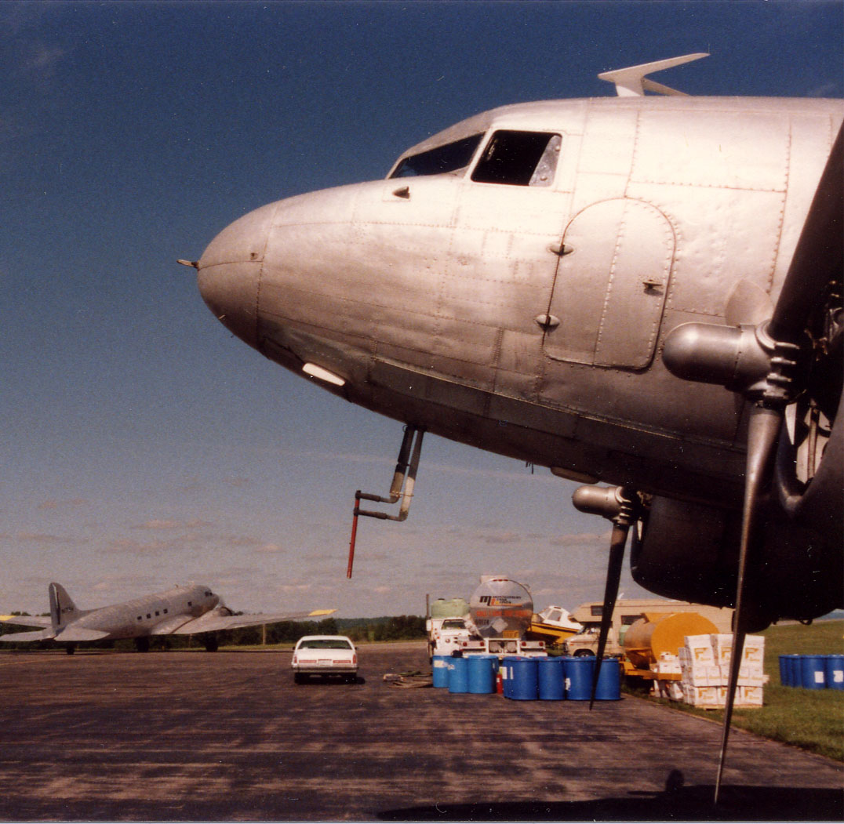
I was only a 1275-hour pilot with one season’s spray experience in a 450-Stearman, and had never had a problem like this before. I asked for advice but got little. I tried everything I could think of, including some things I hardly want to admit, in an effort to get the tail up more quickly.
We tried starting the takeoff roll with the yoke all the way forward and holding it there to force the tail up. Nope. How about sort of “pumping” the elevators as you approach the speed where you think it should come up. ☺ Not real cool either!
Finally, in desperation I got the flight manual out. Yep, you guessed it - - there it was. It said that when the aircraft is loaded toward the aft C.G., you might experience difficulty in raising the tail on takeoff. In that case one was to begin the takeoff roll with the flaps in the “up” position, and at 42-knots, lower them to 1/4 as you simultaneously push forward on the control wheel. Hmm!
It worked! From then until my last load in 1991, it was my standard technique.
It’s funny, how we are sometimes. We insist on trying to figure things out for ourselves when someone else has already “been there and done that.” Reading the instructions is one of the last things some of us want to do.
Trying to figure out how to get the most out of the Douglas sprayer was a challenge. Figuring out how to get the most out of life is an even more complex riddle, but it's much easier when you read the manual!
Who am I, in this crazy world? What is it,that makes life good? When will I be fully satisfied? Why do bad things happen?
Some of the things people do in trying to answer these relentless questions are even more futile than my pumping the elevators on the C-47!
Some try “good,” others “bad,” and still others “things.” Pleasure, psychological gimmicks and other options are on the menu too, but somehow they all leave the questions unanswered!
The Bible is the manufacturer’s manual. We don’t need to figure everything out for ourselves!
The Psalms and Proverbs are the writings of men who experienced God in the realities of life. They wrestled with the meaning of their existence, as we do. As us, they had ups and downs, successes and failures.
Through it all they found God and His "Rules for life" to be good. And they found the significance of life to be in their relationship with Him. Here are some verses I particularly enjoy:
- You will show me the way of life, granting me the joy of your presence and the pleasures of living with you forever. Psalm 16:11
- The Lord says, "I will guide you along the best pathway for your life. I will advise you and watch over you." Psalm 32:8
- Your commands make me wiser than my enemies, for your commands are my constant guide. Psalm 119:98
- Your word is a lamp for my feet and a light for my path. Psalm 119:105
- For these commands and this teaching are a lamp to light the way ahead of you. Proverbs 6:23a
Proverbs has 31 chapters. You might enjoy reading a chapter a day for a month. It’s practical, common sense stuff. Not just for those who think they are “super saints,” but for all who want to understand life better.
Life consists of an endless series of learning experiences. I've learned a lot about God and about life in general by reading the stories in the Old Testament of the Bible. I've seen how things come out for those who go by the book, and those who don't.
One can move on to the New Testament then, to learn who Jesus is; why He came; what He did for us; and how He wants us to live.
From time to time we all find ourselves with questions like "Where do I go from here?" Jesus said, "I am the light of the world. If you follow me, you won't be stumbling through the darkness, because you will have the light that leads to life." (John 8:12)
The Bible is good stuff. Within its pages is the "how to" for the challenges of life. When everything else fails, read the manual! It is written for the non-experts, people who often feel like a "dummy". People like me, who need help along the way!
1999, rev. 7/10, Bible quotations from NLT

Ken Stoltzfus was born in 1940, the son of a crop duster. He has worked as a pilot, pastor, business man, missionary to Africa and writer.
A Commercial Pilot with S&MEL&S, DC-3, Glider and Instrument ratings; CFI with A-I-G ratings; Ground Instructor A&I; and A&P, Ken lives in northeast Ohio with Elaine, his wife of 50 years. His hobbies are aviation photography and collecting aircraft photos, negatives and slides.
This is #9 in his “Flying Higher” series. ©2010, Ken Stoltzfus, www.John2031.com, P.O. Box 228, Kidron, OH 44636 USA

