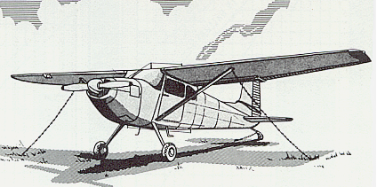

Ken Stoltzfus

Finishing Well
No. 10 in a series
Daring to pursue the highest possible level in all of life
Flying Higher

My father was a “crop duster.” He learned to fly in the mid ‘30’s and was a pioneer in ag aviation.
Doing things well was important to Father. Whether it was rebuilding cars in his body shop, flying airplanes or anything else he did, doing it thoughtfully and deliberately, from start to finish, was important.
Under his tutelage one quickly developed the habit of straightening the tailwheel when positioning for runup. And ramming the throttle was a sure setup for an impromptu father-son session.
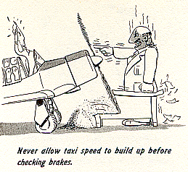
I learned early-on that the centerline on the runway was “the place of choice” for good pilots. Only once did I have to hear, “What are you doing over here? What do you think the centerline is there for?”
Yep, it sounds just like some-thing Father would have said!

Approaches with good airspeed control and a safe glide path were expected. It caused him great anxiety one day when I stopped 1500 feet down the runway in a Cessna 182. It didn't matter that it was the first time this low-time pilot had flown one or that the airspeed indicator wasn't working. Didn't I know that the airspeed indicator was only there to confirm what I already knew from sight and sound!?
Finishing a flight was important. You taxied without dragging the brakes; did S-turns to see over the nose; and didn’t blast other aircraft.
And still one was not done! You put the belt around the stick on the Stearmans, and around the wheel on the Cessna 180 and Twin Beech's, and you put the control locks on the DC-3s.
For Father, these practices and more were simply part of flying.
It was his commitment to excellence that helped him get the Cessna 120 on the ground safely when the fabric came loose on top of the wing and flapped in the breeze.
It enabled him to land the '170 on our unlighted, 2800’ grass strip at night - - with one brake locked up.
And to climb into his newly acquired B-17G (now EAA’s “Aluminum Overcast”) and fly it home to this strip when he had very little multi-engine time and no B-17 checkout.
Over the years Father had nearly 30 forced landings, and not one resulted in enough damage to the aircraft that he couldn’t fly it out!
The late Chris D. Stoltzfus, of Coatesville, PA., concluded his aviation career with 10,000 accident free hours. Many of them were within a few feet of the ground with overloaded dusters. This sort of record is not achieved by chance. Or luck.
I propose that one finishes well, by flying well. By being committed to excellence from start to end. It is an attitude and a commitment.
It is extremely gratifying to see my sons Ken Jr., Brian and Mark, all active Commercial or ATP pilots, walking in a similar path. I trust they will also finish well, but many don’t.
Success can be a precursor to failure if we’re not careful. As Solomon said in Proverbs 16:18, “Pride goes before destruction, and haughtiness before a fall.” The career of many in aviation, business or church work has been marred by the pride that followed success.
Natural skill can kill too, if we let it lead to casualness. Many over-confident jocks have bent their machine when they thought they were good enough to handle anything.
Sincerity is not enough either. My friend was humming a tune as he took off into the pitch-dark night in a Twin Beech on a missionary flight to Haiti. He was still humming as the aircraft descended unchecked into the swamp. The loss of the aircraft was nothing compared to the young couple’s grief over the death of their child.
A mark of Jesus that qualified Him to become our Savior was that He was determined to finish well. Even though He faced challenges bigger than we can imagine, He never blew it. His life was focused. He finished well, because He lived well, from start to finish.
There’s a way in which I’m impressed by some of the bright heads around us these days. The rich young. And the computer whizzes with their technologically enhanced intellects. But I’m going to watch them for a while. They’re off to a fast start but I want to see how they finish.
Will they have wisdom with their knowledge? Will they serve the needs of others, or crush them, with the power in their hands? Will their success lead to gratitude and generosity, or to "attitude" and greed?
The wise will be concerned not only for the moment, but for the long pull. Today's success will be foundational to, tomorrow's. They will apply diligence in all of life, knowing that living well is the foundation for finishing well.
The great Apostle Paul said it well in Philippians 3:12, "I don't mean to say that I have already achieved these things or that I have already reached perfection. But I keep working toward that day when I will finally be all that Christ Jesus saved me for and wants me to be."
That's a good attitude for a safe flight!
1999, rev. 7/10, Bible quotations from NLT

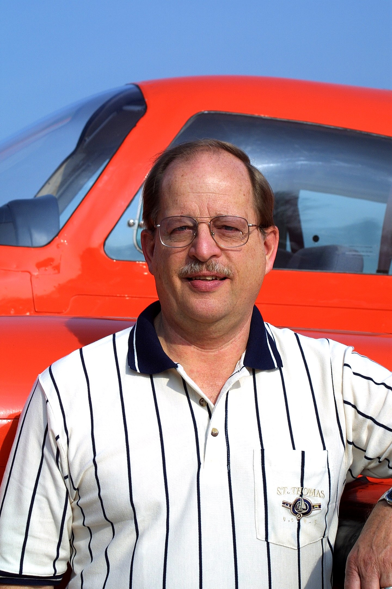
Ken Stoltzfus was born in 1940, the son of a crop duster. He has worked as a pilot, pastor, business man, missionary to Africa and writer.
A Commercial Pilot with S&MEL&S, DC-3, Glider and Instrument ratings; CFI with A-I-G ratings; Ground Instructor A&I; and A&P, Ken lives in northeast Ohio with Elaine, his wife of over 50 years. His hobbies are aviation photography and collecting aircraft photos, negatives and slides.
This is #10 in his “Flying Higher” series. ©2010, Ken Stoltzfus, www.John2031.com, P.O. Box 228, Kidron, OH 44636 USA

