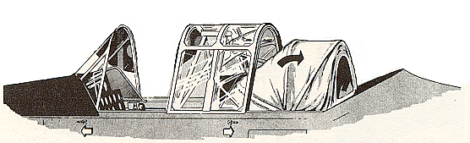

Ken Stoltzfus

Integrated Instruments
No. 6 in a series
Daring to pursue the highest possible level in all of life
Flying Higher

My logbook entry says “5/13/60, Coatesville/Local, T-6G, N400GB, “Integrated Instrument Time.” I remember it well. It was 1960 and my twin brother Karl and I were working on our Private tickets.
Until that time there was no requirement for instrument proficiency for the Private. You learned to fly - - and later you might learn to fly instruments. There was flying, and there was instrument flying.
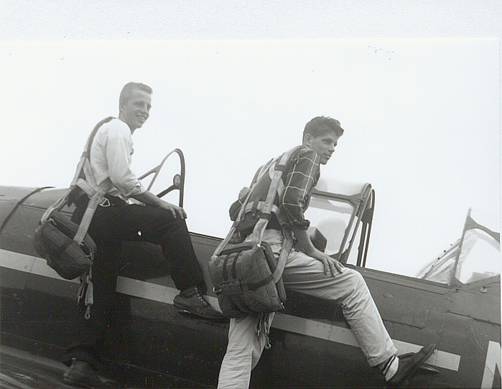
However, a new reg requiring limited instrument proficiency was in the offing. We wanted to get our tickets before it took effect, but we didn’t make it. Shucks, now in addition to learning to fly the T-6 I had to learn to fly instruments! It seemed sort of burdensome to me.
Ken (L) and Karl (R), 1960. The FAA inspector wasn't real sure about wearing the parachute with his suit and tie for our check-rides!
We bought a hood kit for the rear seat of the T-6. It was a folding canvas contraption that you pulled up over your head, very effectively blocking all outside references!
With instructor Bill Hunt in the front cockpit and me in the rear, we took off for what was now called “Integrated Instrument Instruction.” However, it didn’t feel very integrated to me. It felt more like an “add-on,” something you had to do to get by the new rules.
The line between flying, and flying instruments has haunted me some over the years. They have never been one and the same. I’ve loved flying and have done some pretty hard work in forest spraying with Stearmans, Twin Beechs and DC-3s, but that was just “flying.” Mostly VFR unless I had to do the instrument thing once in a while to get to a job site.
Fortunately, early on I became an instructor and learned more about these things. I never fully overcame “the line” personally, but when it came time to teach my sons Ken Jr., Brian and Mark, I taught them “instruments” as a normal part of flying. It was to be one and the same. “That’s how it looks out there, and here’s how it looks on the inside.”
Subsequently, flying instruments is no big deal for them. It's just part of flying. It is truly “integrated” in their experience and makes them better all around pilots. I expect it will be the same for the grandkids.
Many folks struggle with integrating Christianity into everyday life. It’s sort of an “add on” for them - - something for Sundays which has little to do with real life. “Hey, let’s be practical, it’s a ‘dog-eat-dog’ world out there. Sure, I want to go to heaven when I die, but this Christian stuff just doesn’t fit the real world where I live and work!” The line between the two continues to haunt them.
But think about it. Because of the benefits, any serious pilot today will accept the discipline and cost of instrument proficiency. It’s simply part of the game. Likewise, the serious Christian will accept the discipline and cost of making Christianity a way of life. In both cases there are distinct advantages.
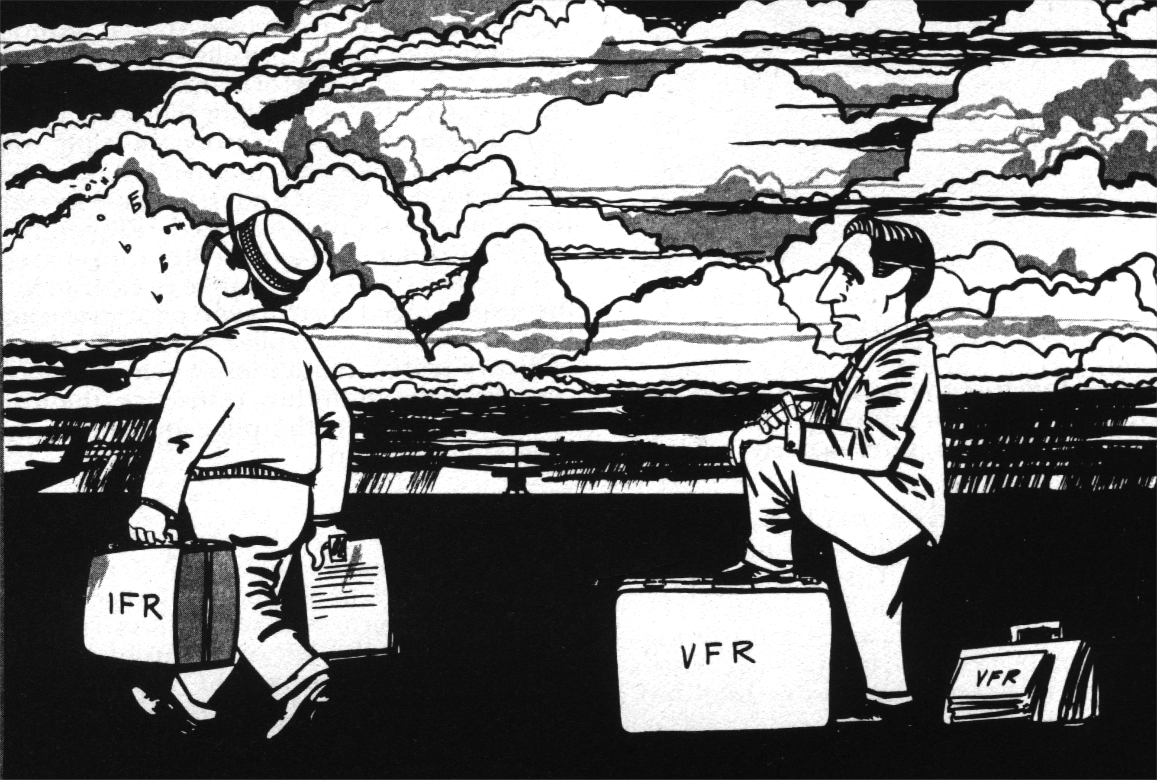
The qualified instrument pilot is much freer of the restraints of bad weather. If properly trained and equipped he can deal with rain, icing and thunderstorms. He can get to his destination with much greater comfort and safety.
Christianity is not just for the “sweet bye and bye,” it's for the “nasty now and now. The man or woman who integrates faith into everyday life has resources to deal with the storms that come our way. And they do!
I've had some pretty heavy thunder bumpers over the years. Watching our fledgling business, Preferred Airparts, burn to the ground in 1982 was not like flying into a beautiful sunset.
I have come to see that God delights in taking broken things and making them into something beautiful. Every time something good was taken from me in life, something better was given. Romans 8:28 is true - -, "And we know that God causes everything to work together for the good of those who love God and are called according to His purpose for them." My family's walk with God was a major factor in our recovery from that fire.
And that's only one of many challenging experiences. Everything worth while that I've ever done was met with at least rain showers, but along the way I came to understand that God wanted to be part of my response to them.
God gives wisdom. Over the years I've made business decisions that were much wiser than me because God was part of them. He delights in doing that for us.
And it's not only Christian, it's just the smart thing to do, to run a business in an ethical way. As I told my sons "way back," even crooks like to deal with honest people.
So there it is. Those who integrate their walk with God, and the rest of life, will benefit greatly. As in flying, life is a trip with a beginning and a destination. And Christianity is not just for our few short years on this earth, it’s for forever! Oct. 1999, rev 7/10, Bible quotations from NLT

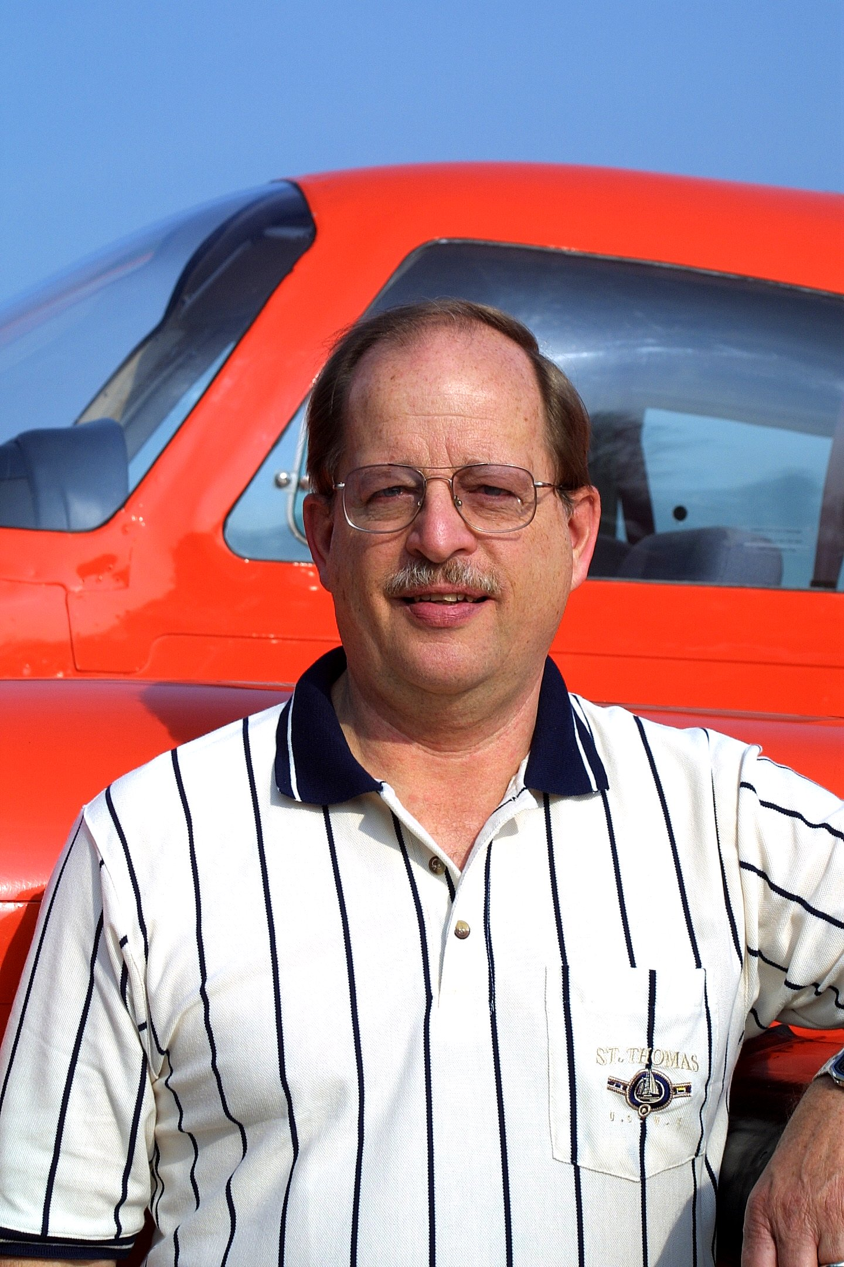
Ken Stoltzfus was born in 1940, the son of a crop duster. He has worked as a pilot, pastor, business man, missionary to Africa and writer.
A Commercial Pilot with S&MEL&S, DC-3, Glider and Instrument ratings; CFI with A-I-G ratings; Ground Instructor A&I; and A&P, Ken lives in northeast Ohio with Elaine, his wife of over 50 years. His hobbies are aviation photography and collecting aircraft photos, negatives and slides.
This is #6 in his “Flying Higher” series. ©2010, Ken Stoltzfus, www.John2031.com, P.O. Box 228, Kidron, OH 44636 USA

