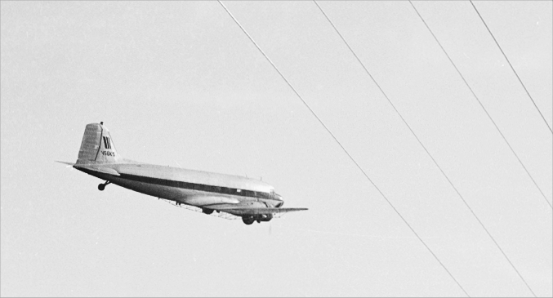

Ken Stoltzfus

"Wires!"
No. 3 in a series
Daring to pursue the highest possible level in all of life
Flying Higher

In my “on and off” career as a spray pilot from 1966-91, I was painfully close to three fatal accidents that resulted from fellow pilots flying into high tension wires.
The first was a 450-Stearman in New York in 1966. Then an AgCat in Pennsylvania in the 1980’s. The third and by far the most devastating for me was my 1959-60, T-6G instructor, a pilot extraordinaire and special friend. A retired airline pilot by 1990, Bill Hunt was the best of the best - - yet the wires yanked his DC-3 out of the sky in West Virginia.
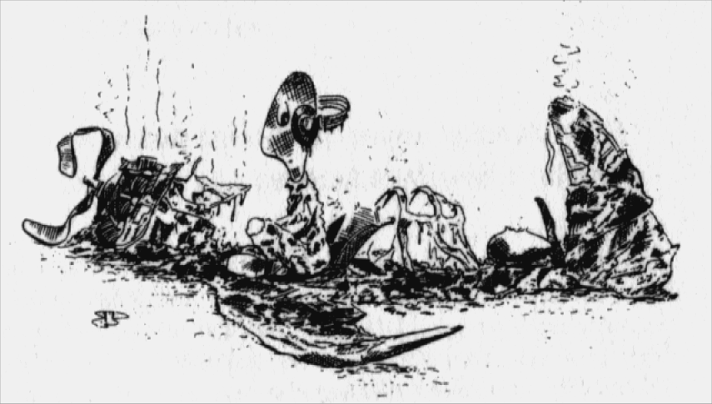
It's scary to think how easily it can happen, and how close I came in the late ‘80’s.
Most pilots are not this fortunate when they fly through high-tension wires!

With one of my sons in the right seat, I was flying the C-47 at our typical 50’ above the trees. Although he was one of the best copilot/navigators I ever had, I wasn't quite trusting his call at the moment and was looking off to the left for ground references.
When I turned back I found myself eyeball to eyeball with some nasty looking cross-country power lines. I sucked the wheel into my gut and we were up and over them, but I’ll never forget the fear and humiliation that filled me in that moment. I apologized to my son but the horror of that event is indelibly inked into my memory.
Here’s some thoughts on how pilots get tangled up in wires. First, while cross-country wires are fairly thick and visible, they have a smaller but deadly ground wire above them. This wire is not “hot,” but it’s often the one that gets us because we’re consciously trying to clear the larger and more visible hot wires. In fact, I suspect that many pilots don't even know the ground wire is there.
Secondly, many of these accidents occur when we focus on terrain beyond the wires as we try to fly a straight spray swath over the forest. This is especially dangerous when there is forest behind the wires instead of their being silhouetted against the sky.
Finally, as in my case, a pilot might be distracted by other things going on around him. Too often we simply fly into the wires without warning.
Life is full of “wires,” i.e. those situations that seem to reach out and pull us down. People are flying into them all the time. Each of us has had at least close encounters and the crash remains of others litter the landscape.
Here are some thoughts on how it happens.
First, we might be doing fairly well at handling major challenges or problems in the workplace, but then a seemingly lesser situation gets us tangled up.
We all deal with multiple challenges. Physical, emotional, financial, relational, professional and other areas vie for our attention. If we focus too much attention and energy in one area and drop our guard in another, we can get tangled up!
I suspect that often we didn't even know that we could get hurt so badly by the things that pulled us down. Frequently it happens at home with the people we love most.
Secondly, there might be things in the distance that we have set our minds on, and we miss stuff up close that can cause us problems. Too often the areas of life that need our attention don't stand out like wires against the sky. They are hidden by the blur of activity that characterizes most of us.
If we’re a visionary or “distant vision” person in life, it helps to have some “near vision” people around us. My wife Elaine has helped me a lot that way over the years. And we should all, always, be ready to hear a word of caution or warning from others.
Finally, we sometimes become distracted by peripheral issues and forget to watch out for the important things ahead. We can do that in a family, business, or any other setting.
Perhaps we’re a micro-manager, “majoring on the minors” instead of trusting those around us. Or sometimes a secondary issue with emotional weight will capture our attention and distract us. There are many ways that good people get their attention off of where they are going!
We must act decisively when we see trouble coming. Like I did in the C-47. For me that has meant calling out to God and making frequent trips into His Word for help. Psalm 25:8, 9 in the Bible says, "The Lord is good and does what is right; he shows the proper path to those who go astray. He leads the humble in what is right, teaching them his way." Yep - - He does just that!
Nobody survived the accidents I spoke of and none of the aircraft were rebuildable. Not even close. But it doesn't need to be that way in life.
It is comforting to know that when we "fly through the wires," we are never so broken that God cannot restore us. In fact, that’s His specialty. As long as there is breath in our lungs there is hope for getting our life put back together if we turn to Him.
Some of you will remember this phrase from the 23rd Psalm, as we used to say it, "The Lord is my shepherd, I shall not want. He maketh me to lie down in green pastures: he leadeth me beside the still waters. He restoreth my soul." (KJV)
God wants to do that for all of us in our time of need, no matter how broken up we are! He is ready, willing and able.


Ken Stoltzfus was born in 1940, the son of a crop duster. He has worked as a pilot, pastor, business man, missionary to Africa and writer.
A Commercial Pilot with S&MEL&S, DC-3, Glider and Instrument ratings; CFI with A-I-G ratings; Ground Instructor A&I; and A&P, Ken lives in northeast Ohio with Elaine, his wife of 50 years. His hobbies are aviation photography and collecting aircraft photos, negatives and slides.
This is #3 in his “Flying Higher” series. ©2010, Ken Stoltzfus, www.John2031.com, P.O. Box 228, Kidron, OH 44636 USA

